Department:

Higher Education and Training

REPUBLIC OF SOUTH AFRICA

|  |  |
| --- | --- |
| |  | | --- | | MARKING GUIDELINE | |

# NATIONAL CERTIFICATE

NOVEMBER EXAMINATION

## STRENGTH OF MATERIALS AND STRUCTURES N5

27 November 2014

This marking guideline consists of 8 pages.



### 1 .1 165XIC2X4

= 99,28 (3)

1 .2

180

### = 4, 1 1 X (2)

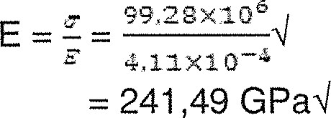1 .3

(2)

[7]

# QUESTION 2

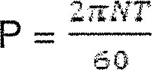

1,350X103x60

75 832,65 Nmq

- 75832,65x1 14M

- 106165,71 NrnN

## 4. 4)

106165571 —x 190x 10 6

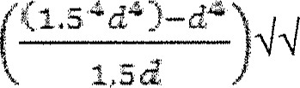

(1.5

16

|  |  |  |
| --- | --- | --- |
| d = 101 |  |  |
| D = 152,49 mrnq  22 |  | (8) |
| 106165,714 X 190 X | X d 3 M |  |
| d = 141,71 mrml |  | (3) |
| 2.3 percentage savings = | X 100 |  |

(3)

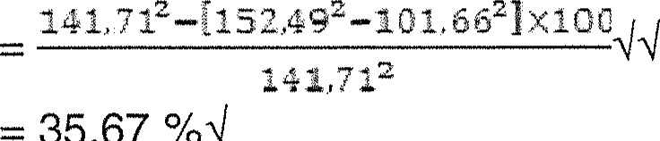

35,67

/04

2.4

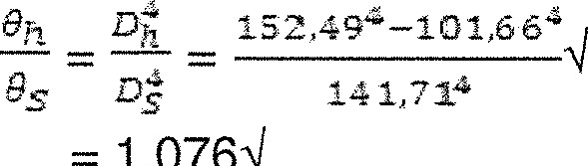

1

,0764

(3)

# QUESTION 3

CMb=ACMb

3.8 x 14 x X)

c





+

53

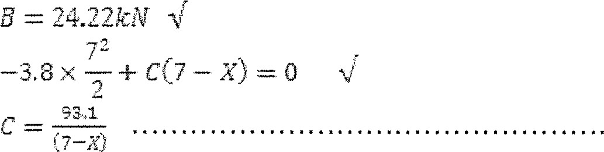(2)4

Equation (1) = equation (2)

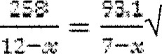

c = 4177

C = 32,979 kNN

|  |  |  |  |  |
| --- | --- | --- | --- | --- |
|  | | 12.62kNV |  |  |
|  | x |  |
|  | 11,6 kNV | Fo | point F  12  4.174 |
|  |
|

4 kN

3,e.xzz

BMB

BMf-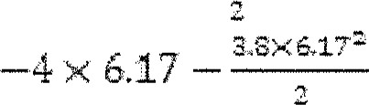+ 2422 x 4,17

3EX41.77Z

BMc=- —33.15kN.mAl

BME= 0

[20]

5t(lP — d)t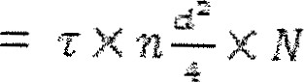

80fP - = 75 xzx

P = 108,82

(2)

Ft = 5t1P — 801108 82 

67,856

(2) fTcX t X d X. N

1 10 24 X 

62,4 kNM (2)



TX

# 75X IT X ± x 2M

67,86 kNM

(2)

62.4 x 10 3

 x locu eox10éx10e22x10-ax10rxto-2

= 0/04

(2) [10]

# QUESTION 5

5.1 fisAs = ccAc

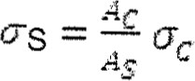

SEC?

1 ,354

At (lac as)

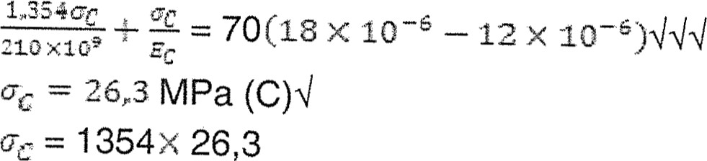1354x 26,3

= 36,61 MPa (TN

(6)

Copyright reserved

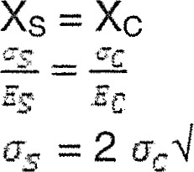

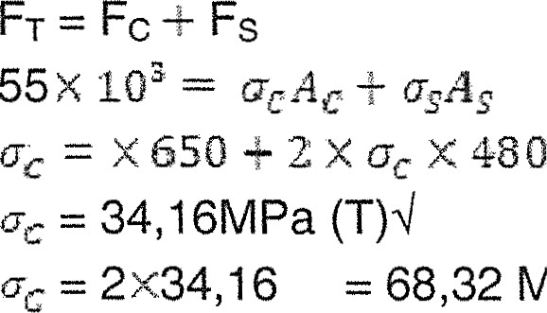68,32 MPa (TN

Resultant stresses

MPa (TN

7,86 MPa (TN

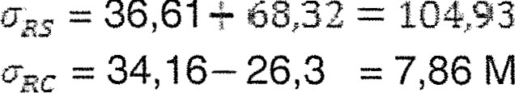

36,61

830 x 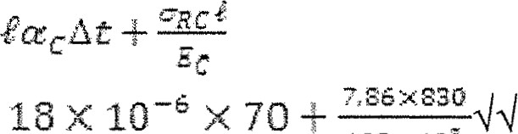18 x IOS X ICE

1,1079 mm

If = 831,1079 rnrnq (3)

[17]

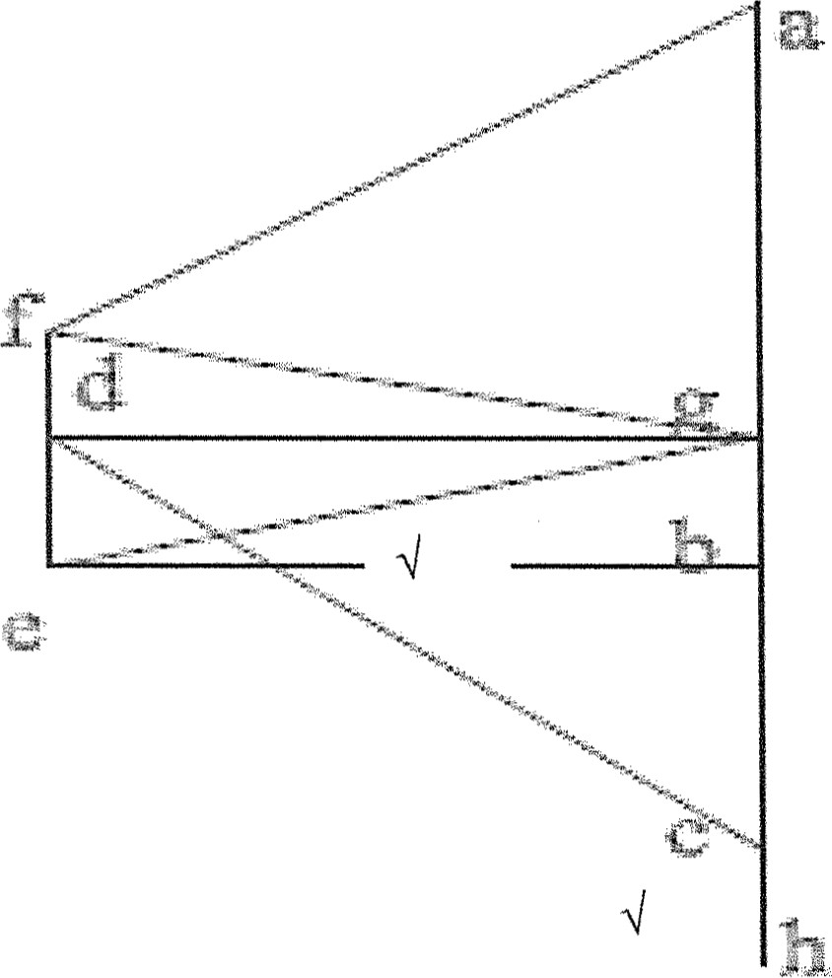

(5)

CM-ACM

IOO x 5 + 50 x9 + 20 x 13R

## R = 93,1 NM

CM = ACM

13 L=100x8+ 50 x 4

## L = 76.9NM (2)

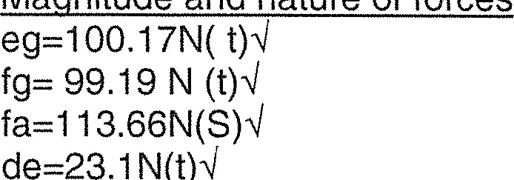Ma nitude and nature of forces

fe=41.53N (S)M

97.47N (S) M dg=97.47N (tw cd-121.83N (8)

[15]

# QUESTION 7

7.1 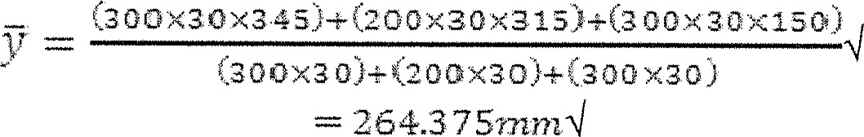

88.175 x

12

+ (30 x 300 x 80625 [1]) +—— 30 s x:co + (200 x 30 x 51625 2 ) 

12

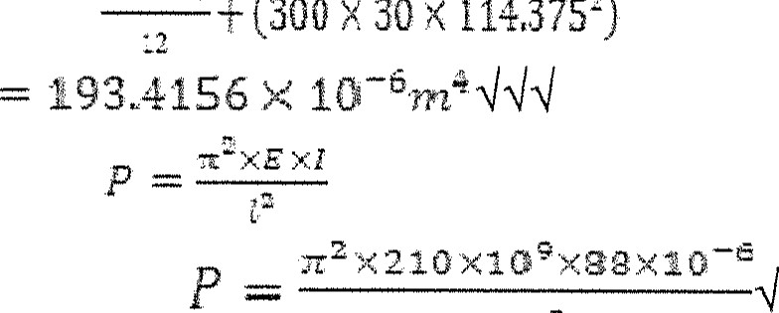

2

--—-+

(300

30

x

114375

)

-8-

7.2 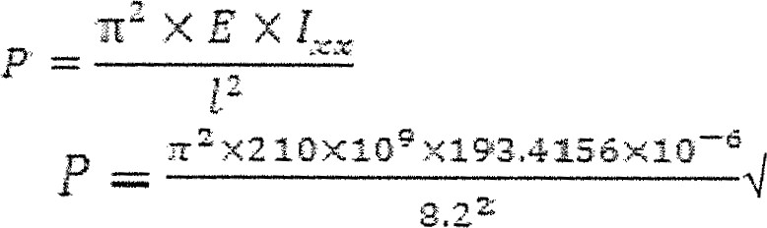

— 5S6MNAI

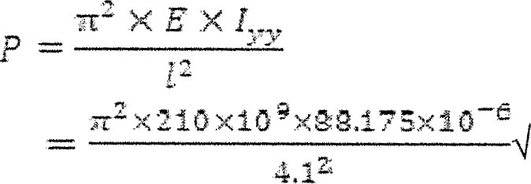

10.87MNM

USE P = 5,96 MNM (5)

[14]

TOTAL: 100

1. 2:22

   2.72MNNl (9)